Learning Guide:

Statue of Liberty

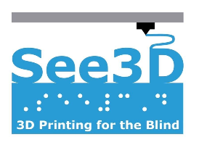

Overview:

The Statue of Liberty is a national monument located in New York. The statue was a gift from France to the United States given out of friendship and has now become a universal symbol of freedom. Additionally, The Statue of Liberty is 305 feet (93 meters) tall.

Model designed by hroncok from
https://www.thingiverse.com/thing:65869
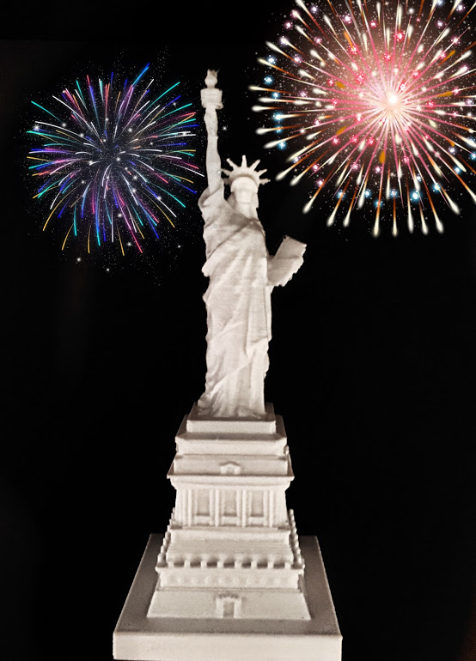
The image above depicts a 3D model of the Statue of Liberty

Walkthrough:

- Place the flat side of the model on a surface, this is the bottom of the model. Start from the highest point of the model and feel for seven triangular spikes. These spikes should be facing towards you.

- Feel the very top of the model. You should feel a sphere-like shape with a rigid top. This is the torch located at the top of the Statue of Liberty. The torch “lights the path to freedom” and symbolizes enlightenment. Since the torch is composed of copper covered in 24 Karat gold, it reflects sunlight during the daytime so it appears that the torch is lit up. During the nighttime, however, 16 floodlights within the torch light up the top of the Statue of Liberty.

- As you move down the model, below the torch, you will feel a long and skinny cylinder shape. This is the right hand of Libertas, the Roman goddess of liberty. She is holding the torch in her right hand above her head.

- Below her arm, the statue will feel textured with raised lines across her body. This is because the woman is wearing a robe with many folds and layers.

- After you feel the robe below her arm, move your finger up until you feel pointy, triangular spikes. There are seven spikes which represent the seven continents and seven seas of the world. The Statue of Liberty symbolizes freedom across the globe, from every continent to every sea.

- Below the crown with the seven spikes, there is the Statue of Liberty’s head. Although the statue is of the Roman goddess, the face is actually of the sculptor’s mother. The face is eight feet tall, which is about half the length of a car.

- As you move down the model and to the right, you will feel a rectangle protruding out of the side of the model. This is a book she is holding in her left hand and the book has the date July 4th, 1776 in Roman numerals (July IV, MDCCLXXVI). This is the day of American independence.

- Keep moving down until you feel a rectangular base of the statue. This base was originally built as a fort but is now open to visitors to see.

Citations:

“Frequently Asked Questions About the Statue of Liberty.” National Parks Service, U.S. Department of the Interior, 2 Apr. 2019, www.nps.gov/stli/planyourvisit/get-the-facts.htm.
Kiger, Patrick J. “Statue of Liberty: The Making of an Icon.” History.com, A&E Television Networks, 14 May 2019, www.history.com/news/statue-of-liberty-icon-building.
“Statue Statistics.” National Parks Service, U.S. Department of the Interior, 6 Aug. 2015, www.nps.gov/stli/learn/historyculture/statue-statistics.htm.

